**PROGRAMS :**

//21co24 Ethan Menezes

//stack implementation in c

#include<stdio.h>

void pop(int* ,int []); //variable declarations

void push(int x,int,int*,int []);

int isFull(int ,int );

int isEmpty(int);

void peek(int,int []);

void display(int ,int []);

int main(){

int c,a[10],size,top=-1,elem;

printf("Enter the size of the stack\n");

scanf("%d",&size);

do{ //menu driven program using switch

printf("1.Push 2.Pop 3.Display 4.Peek 5.Exit\n");

scanf("%d",&c);

switch(c){

case 1:printf("Enter the element to be pushed");

scanf("%d",&elem);

push(elem,size,&top,a);

break;

case 2:pop(&top,a);

break;

case 3:display(top,a);break;

case 4:peek(top,a);break;

case 5:printf("Exiting....");break;

default:printf("Invalid option !\n");

}

}while(c!=5);

return 0;

}

int isFull(int top,int size){ //checks if stack is full or not

if(top==size-1){

return 1;

}

return 0;

}

int isEmpty(int top){ //checks if the stack is empty or not

return (top==-1)?1:0;

}

void pop(int *top,int arr[]){ // pops element from stack

int elem;

if(isEmpty(*top)){

printf("The stack is empty\n");

}

else{

elem=arr[*top];

*top=*top-1;

printf("Element %d has been popped\n",elem);

}

}

void push(int x,int size,int *top,int arr[]){ //pushes element into stack

if(isFull(*top,size)){

printf("Stack overflow\n");

}else{

*top=*top+1;

arr[*top]=x;

printf("Element %d has been inserted\n",x);

}

}

void display(int top, int arr[]){ //display the entire stack

if(isEmpty(top)){

printf("The stack is empty\n");

}else{

printf("The elements of the stack are \n");

for(int i=0;i<=top;i++){

printf("%d\t",arr[i]);

}

printf("\n");

}

}

void peek(int top,int arr[]){ //prints the peek element

if(isEmpty(top)){

printf("The stack is empty\n");

}else{

printf("The peek element is :%d\n",arr[top]);

}

}

Input/Output:

Push operation

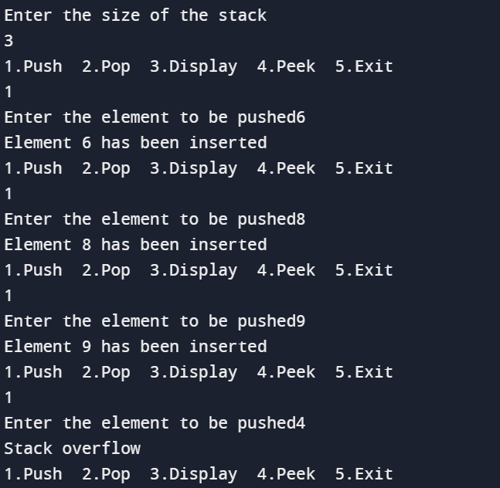

Display stack

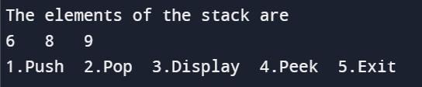

Popping from stack

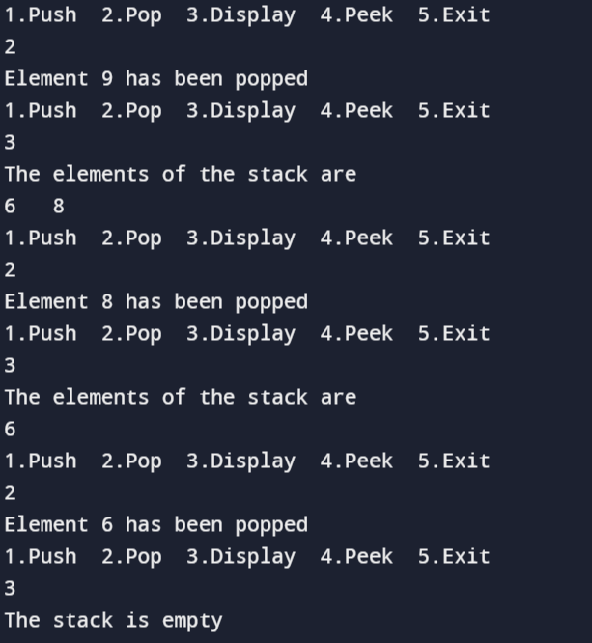

Peek element of stack

